1. Create a keyspace by name Employee
CREATE KEYSPACE employee WITH REPLICATION={ 'class' :
'SimpleStrategy', 'replication_factor' : 1};
USE employee;
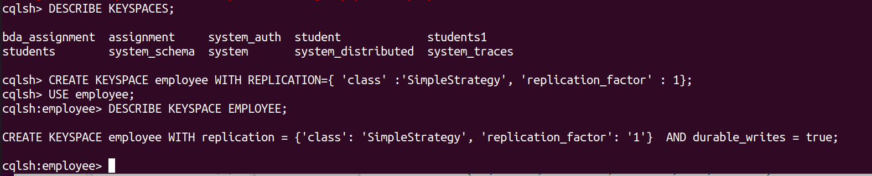

2. Create a column family by name Employee-Info with attributes
Emp_Id Primary Key, Emp_Name, Designation, Date_of_Joining, Salary,
Dept_Name
create table employee_info(emp_id int PRIMARY KEY, emp_name text,
designation text, date_of_joining timestamp, salary double, dept_name text);

3. Insert the values into the table in batch
BEGIN BATCH
INSERT INTO
employee_info(emp_id,emp_name,designation,date_of_joining,salary,dept_name)
VALUES(100,'TANYA','MANAGER','2020-09-11',30000,'TESTING')
... INSERT INTO
employee_info(emp_id,emp_name,designation,date_of_joining,salary,dept_name)
VALUES(111,'SRIRAM','ASSOCIATE','2020-06-22',25000,'DEVELOPING')
... INSERT INTO
employee_info(emp_id,emp_name,designation,date_of_joining,salary,dept_name)
VALUES(121,'SHIVA','MANAGER','2020-03-30',35000,'HR')
... APPLY BATCH;
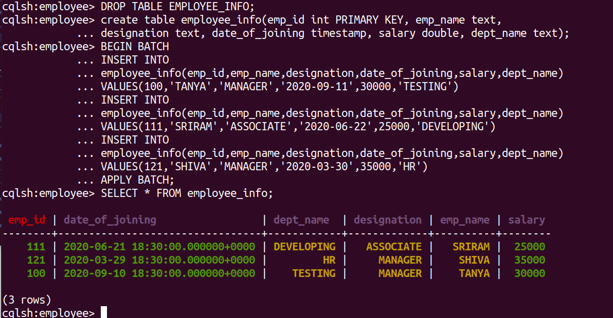
SELECT * FROM employee_info;

4. Update Employee name and Department of Emp-Id 121
UPDATE employee_info SET emp_name = 'SHAAN' WHERE emp_id = 121;
SELECT * FROM employee_info;

5. Sort the details of Employee records based on salary

6. Alter the schema of the table Employee_Info to add a column Projects which
stores a set of Projects done by the corresponding Employee.
ALTER TABLE employee_info ADD projects text;

7. Update the altered table to add project names.
UPDATE employee_info SET projects = 'chat app' WHERE emp_id = 111;
UPDATE employee_info SET projects = 'campusx' WHERE emp_id = 121;
UPDATE employee_info SET projects = 'canteen app' WHERE emp_id = 100;
SELECT * FROM employee_info;
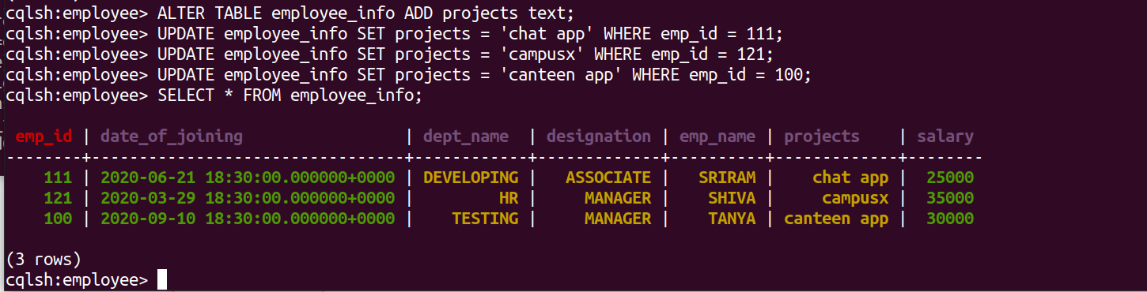

8.Create a TTL of 15 seconds to display the values of Employees .
INSERT INTO
employee_info(emp_id,emp_name,designation,date_of_joining,salary,dept_name)
VALUES(110,'SAM','ASSOCIATE','2020-01-11',33000,'TESTING') USING TTL 15;
SELECT TTL(emp_name) from employee_info WHERE emp_id = 110;
SELECT * FROM employee_info;
